Practical - 5
Practical Title: Registration Form with Frontend Validation and User-Friendly Error Handling

Create a student registration form with HTML5 input types and JavaScript

validation for name, email, mobile number, password, confirm password,

course, year, gender, and terms acceptance. Use Regular Expression for

validations.

Theory

1. Are correct input types and attributes used?
Yes. Appropriate HTML5 input types and attributes are used for each field. For example, email is used for email, tel for mobile number, and password for passwords. Attributes such as required, placeholder, minlength, and maxlength help restrict invalid input and improve form validation.

2. Are validation errors displayed near the relevant fields?
Yes. Validation errors are displayed near the corresponding input field. This makes it easy for the user to identify and correct the invalid information instead of searching for the error elsewhere on the page.

3. Is password strength checked?
Yes. Password strength is checked using JavaScript validation. The password can be evaluated based on conditions such as minimum length, uppercase/lowercase letters, numbers, and special characters. A password-strength indicator can show whether the password is Weak, Medium, or Strong.

4. Is the form accessible using keyboard and screen-reader-friendly labels?
Yes. Each form field should have a properly associated <label> using the for attribute. This allows screen readers to identify the purpose of each input. The form can also be operated using the keyboard by moving between fields with the Tab key and activating controls with the keyboard.
窗体顶端

窗体底端

Implementation/ Output/Result

.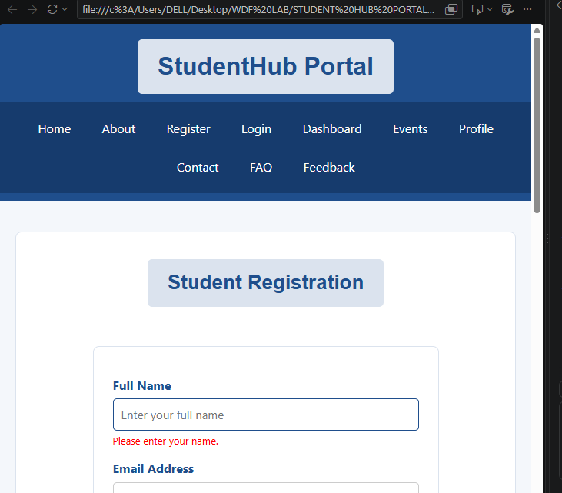
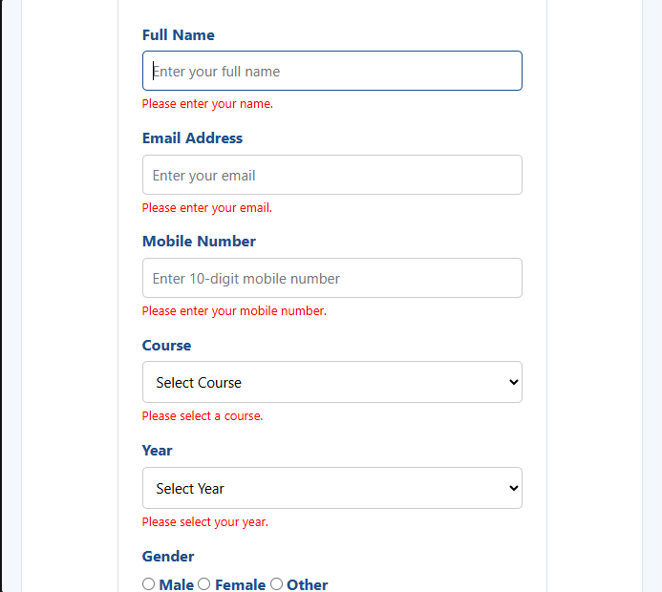
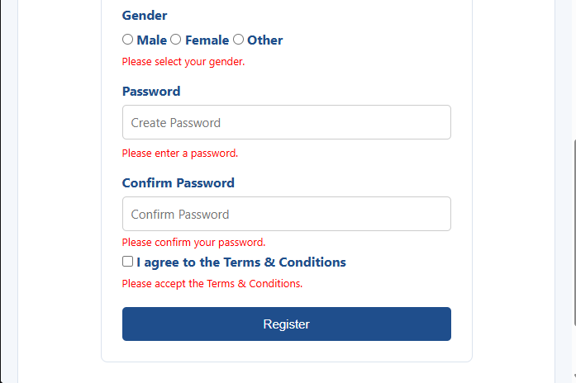
.

Description:

The registration form uses HTML5 and JavaScript to provide proper input validation, user-friendly error messages, password-strength checking, and accessible form controls. These features improve the accuracy, security, usability, and accessibility of the StudentHub registration form.

GitHub Repository Link:

https://github.com/archibhatt091601

Challenges Faced:
• Form validation: Implementing validation for different fields such as name, email, mobile number, password, and confirm password was challenging.
• Regular expressions: Creating and applying suitable regular expressions for email, mobile number, and password validation required careful testing.
• Error messages: Displaying clear and user-friendly error messages near the corresponding fields was challenging.
• Password strength: Implementing the password-strength indicator and checking multiple password conditions required additional JavaScript logic.
• Accessibility: Ensuring that all fields had proper labels and could be accessed using the keyboard required attention to the HTML structure.
• Debugging: Testing valid and invalid inputs and correcting JavaScript errors took time during implementation.

Learning Outcomes:
• Create a student registration form using HTML5 form elements.
• Apply JavaScript validation to validate user inputs such as name, email, mobile number, password, and confirm password.
• Use regular expressions for validating different types of user input.
• Display user-friendly error messages near the relevant form fields.
• Implement password-strength checking to improve password security.
• Design accessible forms using proper labels and keyboard-friendly controls.
• Test and debug the form using both valid and invalid inputs.

Faculty Remarks: (Keep this blank for faculty)

